EUROPEAN REFORMATION RESEARCH GROUP

Wednesday 2 to Friday 4 September 2009

Department of History, University of Plymouth

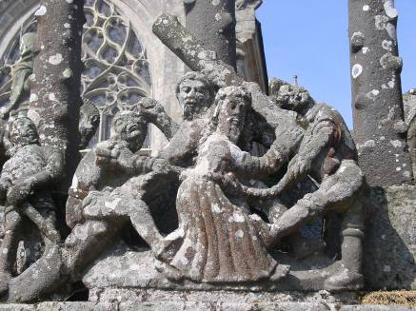
(Calvary, Pleyber-Christ, Finistère, France)

Now in its nineteenth year, the European Reformation Research Group’s annual conference is the United Kingdom’s principal forum for researchers working on all aspects of the Reformation in Europe, including the British Isles, and on related subjects. This year the conference is being hosted by the University of Plymouth.

The conference provides a forum for discussion of new research by postgraduates and researchers in the early part of their careers. Contributions from more senior academics have always been an important ingredient of the conference, and papers from such scholars are also warmly welcomed. Additional bursaries for postgraduates to assist with transport costs are available on application. If you are interested in attending, please contact Liz Tingle or Elaine Fulton, addresses below.

Dr Elizabeth Tingle, general secretary
University of Plymouth
Department of History
4-5 Portland Villas
Plymouth
PL4 8AA
Elizabeth.tingle@plymouth.ac.uk

Dr Elaine Fulton, treasurer
University of Birmingham
Centre for Reformation and Early Modern Studies,
Department of Modern History,
School of Historical Studies,
University of Birmingham,
Birmingham B15 2TT
e.k.fulton@bham.ac.uk

