Empire: Legality, Locality, Authority
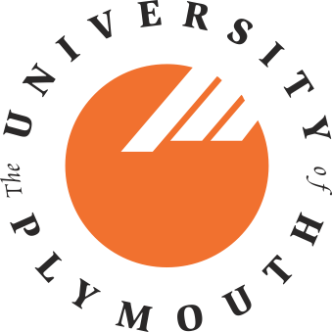
A Symposium at the University of Plymouth 10 September 2010
Organizers: Dr Nandini Chatterjee and Dr Kim Stevenson
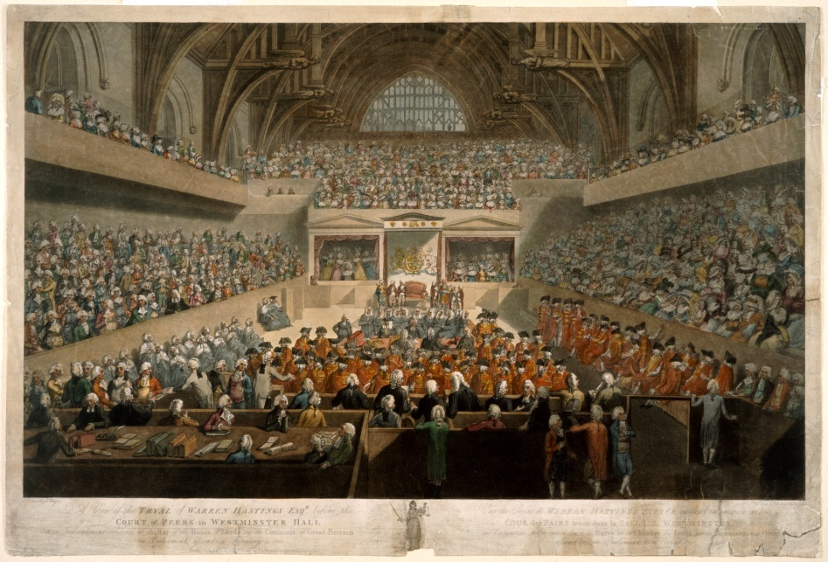

The trial of Warren Hastings by J.R. Polland (1789), courtesy British Library
This multi-disciplinary symposium draws together scholars working within their own disciplinary contexts on the historical connection between law and empire, with the following aims:
- Bringing together a variety of discipline-specific analytical tools to explore how law-bound power is constituted, exercised, justified, represented and transgressed in the inherently unequal context of empire;
- Grappling with methodological problems to identify the most convincing and productive uses of the Privy Council’s records, recently transferred to the National Archives;
- Building a core research team and larger advisory committee to help in conceptualizing, executing, publicizing and attracting funds for the Privy Council project as its grows.
Further details about the project: ‘Judging empire: the global reach of the Judicial Committee of the Privy Council’; Programme and Abstracts are available from the website of the Centre for Humanities, Music and Performing Arts Research, University of Plymouth.
Speakers: Nandini Chatterjee; Lin Holdridge; Stacey Hynd; Diana Jeater; Justin Jones; Stephanie Jones; Stephanie Pratt; Charlotte Smith, Judith Rowbotham; Kim Stevenson; Elizabeth Tingle
Participation in the symposium is free, but spaces are limited.
To register, contact: nandini.chatterjee@plymouth.ac.uk before 16 July 2010.

