‘La France Outremer’:
Expeditions, Encounters and Exchanges

A workshop to be held at The Shakespeare Institute, Stratford-upon-Avon
on Saturday 7 July 2007, 10.30 AM- 5PM.

This workshop will explore the experience of the French overseas during the sixteenth and seventeenth centuries. During this period of early colonial ventures and missionary endeavours there was a fluid and competitive situation for the advancement of European interests overseas. France is often viewed as having lagged behind other European powers in exploiting these opportunities. One of the main concerns of this workshop will be to interrogate this perception through a series of case studies in a variety of geographical contexts.

‘Brazilians’ perform for Henri II at Rouen in 1550
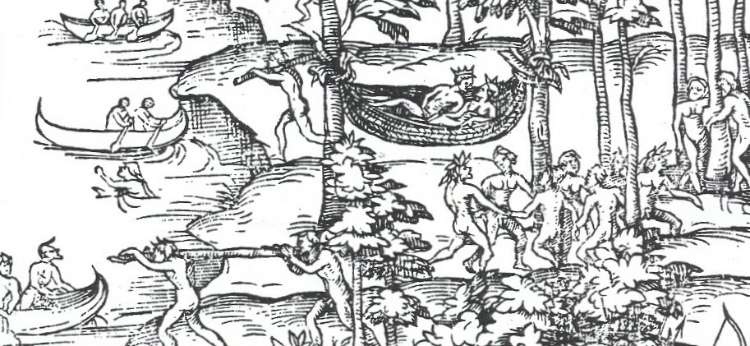

Session 1: Expedition and Diplomatic Exchanges
Alan James (King’s College, London), ‘Building a French empire? The Azores expeditions, 1580-3’
Daniel Bamford (University of Birmingham), ‘French diplomatic engagement with the Ottoman Empire’

Session 2: Mission and Encounters
Megan Armstrong (McMaster University, Ontario), ‘French Franciscans in Palestine’
Gillian Weiss (Case Western Reserve University, Ohio), ‘French slave liberation from seventeenth-century north Africa’

Session 3: Policy and Representation
Sara Chapman (Oakland University, Michigan), ‘A French ‘New World’: French colonial policy under Henri IV’
Graeme Kemp (University of St Andrews, Scotland), ‘The Representation and construction of Outremer in popular print during the reign of Louis XIII’

Many thanks to the University of Warwick and the University of Birmingham’s Centre for Reformation and Early Modern Studies for their generous support of this event. For further information see www.crems.bham.ac.uk/conference.htm, or contact Penny Roberts penny.roberts@warwick.ac.uk or Graeme Murdock g.murdock@bham.ac.uk.

‘La France Outremer’: Expedition, Encounters and Exchanges

Registration

To register for this workshop please complete and return the form below as soon as possible, and by 10 June 2007 at the latest.

The cost of registration is £20 (full) or £15 (student/unwaged). This includes the workshop fee, lunch and refreshments. Please make cheques payable to ‘University of Birmingham’. Return to Graeme Murdock, Centre for Reformation and Early Modern Studies, Department of Modern History, School of Historical Studies, University of Birmingham, B152TT

_____________________________________________________________________

Name:

Contact details (include email):

