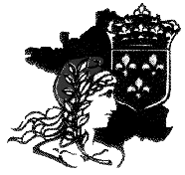
The Society for the Study of French History

Twenty-First Annual Conference
1st – 3rd July 2007, University of St Andrews, UK

PROGRAMME OF EVENTS

SPONSORED BY:
The British Academy
The Royal Historical Society
School of History, University of St Andrews

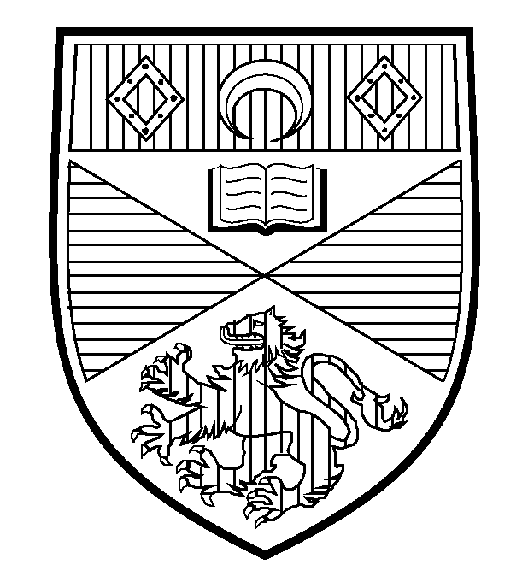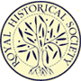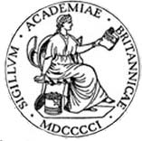

-----------------------------------------------------------------------------------------------------
All plenary and parallel session rooms are in the St Salvator Schools quadrangle.
-----------------------------------------------------------------------------------------------------

Day One: Sunday 1st July 2007

Time Event Venue

18.00 – 19.30 Welcoming Drinks Reception School of Art History,
and Registration The Scores

-----------------------------------------------------------------------------------------------------

Day Two: Monday 2nd July 2007

Time Event Venue

07.30 – 08.30 Breakfast New Hall
[08.15-09.00 SSFH Committee meeting Schools Rm 30]

08.30 – 09.15 Coffee and Registration Upper College Hall

09.15 – 10.30 Plenary 1: Prof Andrew Pettegree Schools Lec Rm 3
University of St Andrews:
“Print Culture in Sixteenth-Century France”
Chair: Professor Mark Greengrass
(University of Sheffield)

10.30 – 11.00 Coffee Upper College Hall

The Society for the Study of French History

Day Two: Monday 2nd July 2007 (cont)

Time Event Venue

11.00 – 13.00 Parallel Sessions 1 Various

1A | 1B | 1C | 1D
Room 31 | 50 | 30 | 32
Robert Knecht and Sixteenth-Century France  David Potter: ‘The French Court’  Mark Greengrass: ‘The French Renaissance’  Chair: Penny Roberts  Respondent: Robert Knecht | Eighteenth-Century Foreign Policy and Diplomacy  Marsha Frey: ‘Brilliant Butterflies of the Panniers Age: The Fate of Diplomats during the French Revolution’  Linda Frey: ‘And then there were none: the Destruction of a Diplomatic Corps, 1792-1799’  Sven Externbrink: ‘Louis XV and Foreign Policy. A Reassessment’  Chair: Guy Rowlands | Revolutionary Tensions, 1830-1848  Greg Burgess : ‘The Romance and Disillusion of Exile. Polish Nationalists and the Early July Monarchy’  Laura O’Brien : ‘Fear and Loathing in La République : Satire and les peureux in 1848’  Christopher Guyver : ‘Alfred de Falloux, the National Workshops and the June Days of 1848’  Chair : Máire Cross | The Modern French Left  Daniel Gordon : ‘French and Immigrant Workers united ? The French Left and Anti-Racist Movements of the 1970s’  Bent Boel : ‘The French Left and Dissidence in Eastern Europe, 1968-1989’  Sue Collard : ‘Parallel Lives, Parallel Archives ? The Archives of François Mitterrand’  Chair : Julian Wright

13.00 – 14.00 Lunch Lower College Hall

14.00 – 15.30 Parallel Sessions 2 Various

2A | 2B | 2C | 2D | 2E
Room 32 | 31 | 54 | 30 | 50
Books in Sixteenth-Century France  Pollie Bromilow: ‘Books for the Girls? Female Readers in Sixteenth-Century France’  Alexander Wilkinson:  'The survival and loss of books published in French before 1601. An analysis of the Bibliothèques of Antoine du Verdier and François de La  Croix du Maine'  Chair: Malcolm Walsby | Court Society under Louis XIV  Giora Sternberg: ‘Epistolary Ceremonial: Towards a Reconstruction of a Code System of Aristocratic Social Positioning at the Time of Louis XIV’  Leonhard Horowski: ‘The Structure of Court Faction at Versailles and its Relevance to eighteenth-century Political History’  Chair: Peter Campbell | Seizing Property in the Revolutionary and Napoleonic Period  Noelle Plack : ‘The Spoils of War : Napoleon’s Seizure and Sale of Common Land in 1813’  Katherine Cox: ‘”Vestiges of Vanity and Pride": France's Feudal Heritage and the Archives Nationales, 1789-1794’  Chair: Rafe Blaufarb | Women in the Nineteenth Century and 3rd Republic  Elizabeth Macknight : ‘Aristocratic Motherhood in Third Republic France, 1870-1940’  Linda Clark : State, Society and Women’s Careers in pre-1914 France : an Assessment’  Chair: Siân Reynolds | France, Spain and Italy in the Inter-War Period  Michelle Perkins : ‘French Anti-Fascist Women and Social Action on Behalf of the Spanish Republic, 1936-9’  Sandrine Iraci : ‘French Cultural Policy in Italy from the End of the First World War to the Beginning of Fascism (1918-1922) : a General Overview’  Chair : Tim Baycroft

The Society for the Study of French History

Day Two: Monday 2nd July 2007 (cont)

Time Event Venue

15.30 – 16.00 Tea Upper College Hall

16.00 – 17.30 Plenary 2: Schools Lec Rm 3
“The Future of the French Archives” (in French):
M. Bruno Galland
(Archives de France);
M. Thierry Sarmant
(Bibliothèque Nationale de France)
Chair: Siân Reynolds

17.30 – 18.50 Parallel Sessions 3 Various

3A | 3B | 3C | 3D | 3E
Room 32 | 30 | 54 | 31 | 50
Religious Commitment in the Era of the Wars of Religion  Sara Barker: ‘«Vne cause ciuile & politique»? Rethinking the Conspiracy of Amboise’  Eric Nelson: ‘The Impact of Catholic Renewal on the Rural Processional Life of the Blaisois’  Chair: Megan Armstrong | Religion and the Enlightenment  Ambrogio Caiani: ‘The Eucharistic Revolution: Court, Religion and Ritual at the Twilight of the Bourbon Monarchy’  Jeffrey Burson: ‘Religious Politics and Polarization in European Enlightenment: a Case of French Exceptionalism?’  Chair: Peter Campbell | Artistic Performance in Nineteenth-Century France  William Weber : ‘The Revolutionary Origins of the Quartet Concert, 1804-1848’  Gretchen Elizabeth Smith : ‘Femme fatale : the Actress in French Novels and Plays’  Chair : Christopher Guyver | France, Germany and Alsace in the early 20th Century  Conan Fischer : ‘ « Charmante adversaire et terrible ami » : a Reappraisal of German Policy towards France from the Boer War to Locarno’  Alison Carrol : ‘The SFIO and the Question of Eduction in Interwar Alsace’  Chair : Stephen Tyre | Nature and Environment in the Modern Francophone World  Marie-Paule Ha : ‘Imperial Hygiene in the Torrid Zones’  Chris Pearson : ‘In Search of maquis (and other Habitats : Nature in Vichy France’  Chair : John Strachan

19.30 for 20.00 Drinks and Dinner Lower College Hall

----------------------------------------------------------------------------------------------------------------

Day Three: Tuesday 3rd July 2007

Time Event Venue

07.45 – 08.45 Breakfast New Hall

The Society for the Study of French History

Day Three: Tuesday 3rd July 2007 (cont)

Time Event Venue

09.00 – 10.15 Society ANNUAL GENERAL MEETING Schools Lec Rm 3
(Members of the Society only)
OR
Guided Tour of St Andrews Meet: St Salvator’s
(non-members) Tower (9am)

10.15 – 10.45 Coffee Upper College Hall

10.45 – 12.45 Parallel Sessions 4 Various

4A | 4B | 4C | 4D | 4E
Room 32 | 30 | 54 | 50 | 31
Security in the Periphery under Louis XIV  Philip McCluskey: ‘French Occupation of the Duchies of Lorraine and Savoie under Louis XIV’  Gregory Monahan: ‘Our Poor Allies: the Camisards and His Grace the Duke of Marlborough’  Sara Chapman: ‘Colonial Policy in New France during the later Reign of Louis XIV, c.1680-1715’  Chair: David Parrott | Revolutionary and Napoleonic France : Trans-national Comparisons, Transfers and Circulation of Knowledge  Pierre-Yves Lacour: ‘Les confiscations françaises de collections naturalistes en Europe septentrionale et en Italie’  Valeria Pansini : ‘Saisir des cartes et des hommes : la politique de conquête des institutions topographiques françaises (1794-1815)’  Comment : Bernhard Struck  Chair : Jakob Vogel | Books and Audiences in Eighteenth- and Nineteenth-Century France  Siân Reynolds: ‘Reading Candide on the Ile de la Cité: Manon Phlipon’s Approach to Books’  Sophie Heywood : ‘The 'Calvary' of the Comtesse de Ségur: Writing, Censorship and the Reading Public under the Second Empire’  Isabel DiVanna : ‘A Nation needs Books ! Nineteenth-century Medievalists and the Popularisation of Medieval Legends’  Chair : Judith DeGroat | The Right in the 3rd Republic and World War Two  Martin Simpson : ‘Imagining France : the Right and Ideas of the French Nation in the late Nineteenth Century’  Jessica Wardhaugh : ‘ « Un rire nouveau » : Action Française and the Art of Political Satire’  Sheila Nowinski : ‘French Catholic Political Culture between Vichy and the Fourth Republic : François Mauriac’s Journalism, 1944-1946’  Chair : Julian Wright | War and Memory in Modern French History  Karine Varley: ‘”The Greatest Military Collapse recorded by History” (Henry Houssaye): Perceptions of the Defeat of 1870-1 and French Identity’  Claire Eldridge: ‘Mon père ne nous en a jamais parlé.’ The Role of cadres sociaux in the Construction of the “Memory” of the fils de harkis’  Chair : Stephen Tyre

12.45 – 13.45 Lunch Lower College Hall
The Society for the Study of French History

Day Three: Tuesday 3rd July 2007 (cont)

Time Event Venue

13.45 – 15.45 Parallel Sessions 5 Various

5A | 5B | 5C | 5D | 5E
Room 32 | 54 | 30 | 31 | 50
Catholicism in the Era of the Religious Wars  Luc Racaut: ‘Catholic Reformation in Print during the French Wars of Religion’  Alison Forrestal : ‘Vincent de Paul: Formation and Leadership amongst Catholic Dévots’  Katy Gibbons: ‘Histoire tragique – Edward II of England and Henri III of France: the Use of English Historical Examples by Catholic Propagandists in Later Sixteenth-Century France’  Chair: Eric Nelson | Working with “the Other” and the Foreign (17th-19th centuries)  Junko Takeda: ‘Marseilles: a Peripheral Center or a Central Periphery? Demi-Orientalism and French Inventions of the Mediterranean, 1660-1777’  Bertie Mandelblatt: ‘“Two and a half pots of manioc flour, or three cassavas”: the Code noir, the Consumption of Slaves and Slaves’ Consumption in the ancien régime French Atlantic’  Helen Smith: ‘The Incidence of Smuggled Goods in France in the 2nd Half of the 18th and Early Part of the 19th Centuries’  Chair: Sara Chapman | Defending the Revolution and Empire  Mette Harder : ‘The National Representation under Attack? The Convention and the Assassination Attempt against Jean-Lambert Tallien in Fructidor Year II’  Ian Germani : ‘Military Justice under the Directory : the Armies of Italy and of the Sambre and Meuse’  Joseph Clarke: 'Cenotaphs and Cypress Trees:  Commemorating the dead of the Revolutionary wars, 1792-99'  Chair: Malcolm Crook | The Pageantry of French Collective Memory: the Middle Ages at the Turn-of-the-Century  Elizabeth Emery : ‘Remembrance of a France Past : le vieux Paris at the 1900 World Fair’  Janet Marquardt : ‘The Royals visit Cluny : Commemorating the Medieval Past in 1910’  Chair : Elizabeth Macknight | Intellectual Trajectories of the Interwar Period  Katherine Davies : ‘Tragedy and the Catholic Intellectual in Interwar Paris’  James Mansell : ‘Bergsonism and the Cultural Politics of Time in Paris’s Interwar Avant-Garde’  John Strachan : ‘Paris and Algiers : Interwar Genealogies of Postcolonial Thought’  Chair : Bertrand Taithe

15.45 Tea Upper College Hall

Departure

