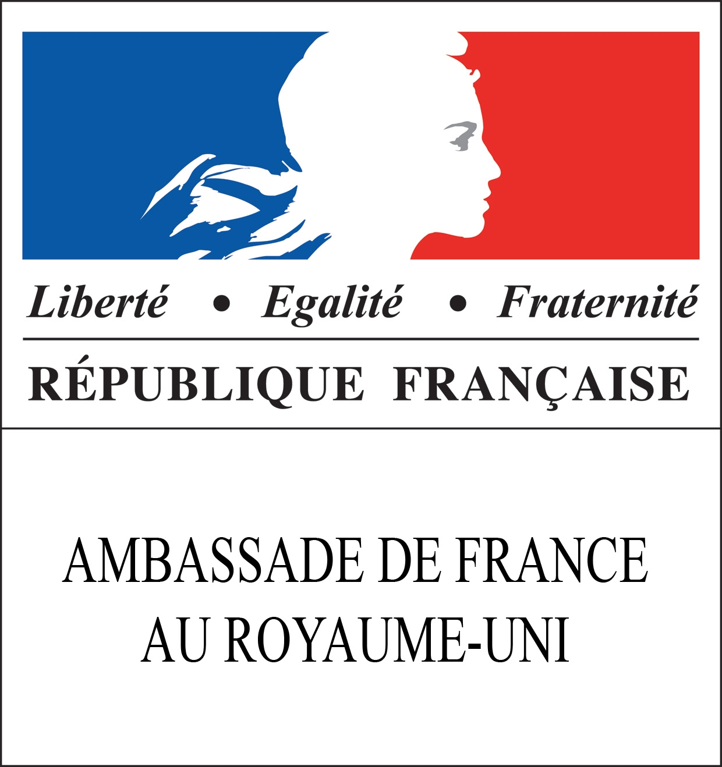

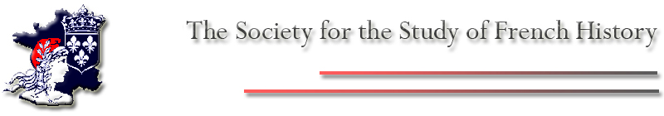

Society for the Study of French History Annual Conference
14-15 July 2011, Fitzwilliam College, University of Cambridge

Theme: Celebrating France

The Society for the Study of French History will be holding its 25th annual conference at Fitzwilliam College, in Cambridge (14-15 July, 2011).

All speakers and panelists have been confirmed. Panels and talks will address several of the following broader topics:

- Memory, nation and identity in French history
- History of cultural festivals, fêtes and celebratory events
- Considerations on key personages of French history
- The construction of a national history or narrative
- Conflicting views about the past
- Theoretical and methodological approaches to the topics of celebrations, memory and the creation of national discourses

Keynote Speakers:

Lynn Hunt, UCLA
Alice Gérard, Paris
Ruth Harris, Oxford

Speakers and Panelists include:

Sara Barker, Exeter
Andrew Barros, Quebec
Hilary Bernstein, California
Elizabeth Bonner, Sydney
Caroline Campbell, North Dakota
Stuart Carroll, York
Alison Carroll, Birkbeck
Claire Courtecuisse, Grenoble
Rémi Dalisson, Rouen
Pascal Firges, Heidelberg
Catherine Culvahouse Fox, Yale
Jennifer Heuer, U Massachusetts
David Gilks, Oxford
Mark Greengrass, Sheffield
Caspar Hirschi, Zurich
David Hopkin, Oxford
Norman Ingram, Concordia
Samuel Kalman, St Francis Xavier
Philippe Knee, Laval, CA
Valerie Mainz, Leeds
Sean McGlynn, Plymouth
Chris Millington, Cardiff
Laura O’Brien, Trinity College, Dublin
Adrian O'Connor, Florida
Declan O'Reilly, UEA
Francesco Pigozzo, Pisa
Noelle Plack, Newman College, Birmingham
Pamela Pilbeam, Royal Holloway, University of London
William Pooley, Oxford
Sian Reynolds, Stirling
Zita Rohr, Sydney
Giora Sternberg, Harvard
Eric Storm, Leiden
Richard Taws, UCLA
Moshik Temkin, Harvard
Maike Their, UCLA
James Tucker, Warwick
Stephen Tyre, St Andrews
Karine Varley, Strathclyde
Louisa Zanoun, Concordia

Online registration is now open

Please contact Dr Isabel DiVanna (id239@cam.ac.uk) if you have any queries.

For and on behalf of the Conference Organisers: Robert Tombs, Emma Spary, Michael Sonenscher, Ruth Scurr, Sylvana Tomaselli, Sarah Howard, Isabel DiVanna, Pernille Røge, Tom Stammers and Felicity Green.

With the generous support of the service culturel de l'Ambassade de France au Royaume-Uni, and of the Royal Historical Society

